

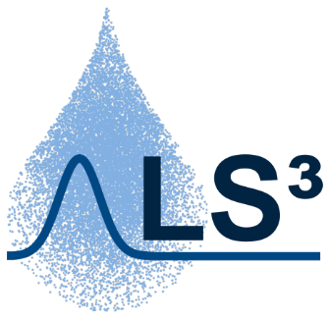

James Bond

**On the Optimization and Uncertainty Quantification of Groundwater Models**

Master Thesis

**On the Optimization and Uncertainty Quantification of Groundwater Models**

Submitted by

James Bond

Matriculation Number: 0000007

Examiners: Prof. Dr.-Ing. Wolfgang Nowak

Dr.-Ing. habil. Sebastian Pfannkuchenmann

Supervisors: Prof. Dr. Reiner Schmidt

M.Sc. Be Treuer

Institute for Modeling Hydraulic and Environmental Systems

Department of Stochastic Simulation and Safety Research for Hydrosystems

Stuttgart, XX MONTH 20XX

# Author declaration

I declare that I have developed and written the enclosed thesis completely by myself and that I have not used sources or means without declaration in the text. Any thoughts from others or literal quotations are clearly marked. The thesis was not used in the same or in a similar version to achieve an academic grading or is being published elsewhere. The enclosed electronic version is identical to the printed versions.

Date Signature

# Contents

Author declaration iii

Contents i

List of Figures iii

List of Tables v

1 Chapter Bla Bla 1

1.1 Equations 1

1.1 Figures 2

1.2 References 3

2 Summary and Conclusions 5

2.1 Section Bla Bla 5

2.1.1 Section Bla Bla Bla 6

2.1.2 Section Bla Bla Bla 6

2.2 Section Bla Bla 7

Bibliography 9

# List of Figures

Figure 1.1: Cross section and plan view of the channel 2

# List of Tables

Table 1.1: An example table 1

# Chapter Bla Bla

This test sentence is supposed to span more than one line. Or maybe, we need another sentence for this. And why, you ask, do we need several lines at all? Well, to test the line spacing, of course! Please have a look at Table 1.1.

|  |  |
| --- | --- |
| Title col-1 | Title col-2 |
| Bla | Bla |
| Bla | Bla |

Table 1.1: An example table

## Equations

One way to include equations in the document is using a two-column table with “no borders”. Please see Eq. (1) as an example.

|  |  |
| --- | --- |
| $${\left(x+a\right)}^{n}=\sum_{k=0}^{n}{\left({n \atop k}\right)x^{k}a^{n-k}}$$ | (1) |

You can use the “Equation” tool from the “Insert tab” to write down the equation.

Bla Bla Bla bla Bla Bla bla Bla Bla bla Bla Bla bla Bla Bla bla Bla Bla bla Bla Bla bla Bla Bla bla Bla Bla bla Bla Bla bla Bla Bla bla Bla Bla bla Bla Bla bla Bla Bla bla Bla Bla bla Bla Bla

bla Bla Bla bla Bla Bla bla Bla Bla bla Bla Bla bla Bla Bla bla Bla Bla bla Bla Bla bla Bla Bla bla Bla Bla bla Bla Bla bla Bla Bla bla Bla Bla bla Bla Bla bla Bla Bla bla Bla Bla bla Bla Bla bla Bla Bla bla Bla.

Bla bla Bla Bla bla Bla Bla bla Bla Bla bla Bla Bla bla Bla Bla bla Bla Bla bla Bla Bla bla Bla Bla bla Bla Bla bla Bla Bla bla Bla Bla bla Bla Bla bla Bla Bla bla Bla Bla bla Bla Bla bla Bla. Bla bla Bla Bla bla Bla Bla bla Bla Bla bla Bla Bla bla Bla Bla bla Bla Bla bla Bla Bla bla BlaBla bla Bla Bla bla Bla Bla bla Bla Bla bla Bla Bla bla Bla Bla bla Bla Bla bla Bla Bla bla Bla.

## Figures

Now you have an example of a figure. Please see Figure 1.1. Bla bla Bla Bla bla Bla Bla bla Bla Bla bla Bla Bla bla Bla Bla bla Bla Bla bla Bla Bla bla Bla.

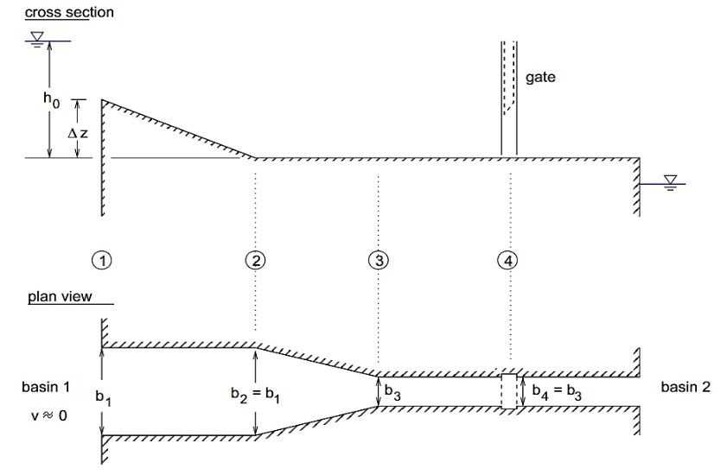

Figure 1.1: Cross section and plan view of the channel

Bla bla Bla Bla bla Bla Bla bla Bla Bla bla Bla Bla bla Bla Bla bla Bla Bla bla Bla Bla bla Bla

Bla bla Bla Bla bla Bla Bla bla Bla Bla bla Bla Bla bla Bla Bla bla Bla Bla bla Bla Bla bla BlaBla bla Bla Bla bla Bla Bla bla Bla Bla bla Bla Bla bla Bla Bla bla Bla Bla bla Bla Bla bla Bla Bla bla Bla Bla bla Bla Bla bla Bla Bla bla Bla Bla bla Bla Bla bla Bla Bla bla Bla Bla bla Bla Bla bla Bla Bla bla Bla Bla bla Bla Bla bla Bla Bla bla Bla Bla bla Bla Bla bla Bla Bla bla Bla.

Bla bla Bla Bla bla Bla Bla bla Bla Bla bla Bla Bla bla Bla Bla bla Bla Bla bla Bla Bla bla BlaBla bla Bla Bla bla Bla Bla bla Bla Bla bla Bla Bla bla Bla Bla bla Bla Bla bla Bla Bla bla Bla Bla bla Bla Bla bla Bla Bla bla Bla Bla bla Bla Bla bla Bla Bla bla Bla Bla bla Bla Bla bla Bla.

Bla bla Bla Bla bla Bla Bla bla Bla Bla bla Bla Bla bla Bla Bla bla Bla Bla bla Bla Bla bla BlaBla bla Bla Bla bla Bla Bla bla Bla Bla bla Bla Bla bla Bla Bla bla Bla Bla bla Bla Bla bla Bla Bla bla Bla Bla bla Bla Bla bla Bla Bla bla Bla Bla bla Bla Bla bla Bla Bla bla Bla Bla bla Bla Bla bla Bla Bla bla Bla Bla bla Bla Bla bla Bla Bla bla Bla Bla bla Bla Bla bla Bla Bla bla Bla.

## References

For references you can use the “Zotero” or either “Mendeley”. Both softwares help you easily cite your sources as you write and are convenient when your document handles many bibliographic references.

You may use a numerical referenciation such as the following. Here we mention reference [1] and here reference [2]. Later on the document will appear references [3-5] and so on. References within the “Bibliography” section are organized in numerical ascending order.

Also, you may choose to use a referenciation with author name and year. For this document we used “author year”. Therefore, references appear in the “Bibliography” section in alphabetical order. Here you have an example of this (Braak, 2006; Illman, Berg, & Zhao, 2015) and here another one (Nowak & Guthke, 2016). And here we have third example of a reference of Schöniger et al. (2015). Alternatively, you may choose to enter the references manually.

# Summary and Conclusions

Bla bla Bla Bla bla Bla Bla bla Bla Bla bla Bla Bla bla Bla Bla bla Bla Bla bla Bla Bla bla BlaBla bla Bla Bla bla Bla Bla bla Bla Bla bla Bla Bla bla Bla Bla bla Bla Bla bla Bla Bla bla Bla Bla bla Bla Bla bla Bla Bla bla Bla Bla bla Bla Bla bla Bla Bla bla Bla Bla bla Bla Bla bla Bla Bla bla Bla Bla bla Bla Bla bla Bla Bla bla Bla Bla bla Bla Bla bla Bla Bla bla Bla Bla bla Bla. Bla bla Bla Bla bla Bla Bla bla Bla Bla bla Bla Bla bla Bla Bla bla Bla Bla bla Bla Bla bla BlaBla bla Bla Bla bla Bla Bla bla Bla Bla bla Bla Bla bla Bla Bla bla Bla Bla bla Bla Bla bla Bla Bla bla Bla Bla bla Bla Bla bla Bla Bla bla Bla Bla bla Bla Bla bla Bla Bla bla Bla Bla bla Bla Bla bla Bla Bla bla Bla Bla bla Bla Bla bla Bla Bla bla Bla Bla bla Bla Bla bla Bla Bla bla Bla. Bla bla Bla Bla bla Bla Bla bla Bla Bla bla Bla Bla bla Bla Bla bla Bla Bla bla Bla Bla bla BlaBla bla Bla Bla bla Bla Bla bla Bla Bla bla Bla Bla bla Bla Bla bla Bla Bla bla Bla Bla bla Bla Bla bla Bla Bla bla Bla Bla bla Bla Bla bla Bla Bla bla Bla Bla bla Bla Bla bla Bla Bla bla Bla Bla bla Bla Bla bla Bla Bla bla Bla Bla bla Bla Bla bla Bla Bla bla Bla Bla bla Bla Bla bla Bla.

## Section Bla Bla

Bla bla Bla Bla bla Bla Bla bla Bla Bla bla Bla Bla bla Bla Bla bla Bla Bla bla Bla Bla bla BlaBla bla Bla Bla bla Bla Bla bla Bla Bla bla Bla Bla bla Bla Bla bla Bla Bla bla Bla Bla bla Bla Bla bla Bla Bla bla Bla Bla bla Bla Bla bla Bla Bla bla Bla Bla bla Bla Bla bla Bla Bla bla Bla Bla bla Bla Bla bla Bla Bla bla Bla Bla bla Bla Bla bla Bla Bla bla Bla Bla bla Bla Bla bla Bla. Bla bla Bla Bla bla Bla Bla bla Bla Bla bla Bla Bla bla Bla Bla bla Bla Bla bla Bla Bla bla BlaBla bla Bla Bla bla Bla Bla bla Bla Bla bla Bla Bla bla Bla Bla bla Bla Bla bla Bla Bla bla Bla Bla bla Bla Bla bla Bla Bla bla Bla Bla bla Bla Bla bla Bla Bla bla Bla Bla bla Bla Bla bla Bla Bla bla Bla Bla bla Bla Bla bla Bla Bla bla Bla Bla bla Bla Bla bla Bla Bla bla Bla Bla bla Bla. Bla bla Bla Bla bla Bla Bla bla Bla Bla bla Bla Bla bla Bla Bla bla Bla Bla bla Bla Bla bla BlaBla bla Bla Bla bla Bla Bla bla Bla Bla bla Bla Bla bla Bla Bla bla Bla Bla bla Bla Bla bla Bla Bla bla Bla Bla bla Bla Bla bla Bla Bla bla Bla Bla bla Bla Bla bla Bla Bla bla Bla Bla bla Bla Bla bla Bla Bla bla Bla Bla bla Bla Bla bla Bla Bla bla Bla Bla bla Bla Bla bla Bla Bla bla Bla.

### Section Bla Bla Bla

Bla bla Bla Bla bla Bla Bla bla Bla Bla bla Bla Bla bla Bla Bla bla Bla Bla bla Bla Bla bla BlaBla bla Bla Bla bla Bla Bla bla Bla Bla bla Bla Bla bla Bla Bla bla Bla Bla bla Bla Bla bla Bla Bla bla Bla Bla bla Bla Bla bla Bla Bla bla Bla Bla bla Bla Bla bla Bla Bla bla Bla Bla bla Bla Bla bla Bla Bla bla Bla Bla bla Bla Bla bla Bla Bla bla Bla Bla bla Bla Bla bla Bla Bla bla Bla.

Bla bla Bla Bla bla Bla Bla bla Bla Bla bla Bla Bla bla Bla Bla bla Bla Bla bla Bla Bla bla BlaBla bla Bla Bla bla Bla Bla bla Bla Bla bla Bla Bla bla Bla Bla bla Bla Bla bla Bla Bla bla BlaBla bla Bla Bla bla Bla Bla bla Bla Bla bla Bla Bla bla Bla Bla bla Bla Bla bla Bla Bla bla Bla Bla bla Bla Bla bla Bla Bla bla Bla Bla bla Bla Bla bla Bla Bla bla Bla Bla bla Bla Bla bla Bla Bla bla Bla Bla bla Bla Bla bla Bla Bla bla Bla Bla bla Bla Bla bla Bla Bla bla Bla Bla bla Bla. Bla bla Bla Bla Bla bla Bla Bla bla Bla Bla bla Bla Bla bla Bla Bla bla Bla Bla bla Bla Bla bla Bla Bla bla Bla Bla bla Bla Bla bla Bla Bla bla Bla Bla bla Bla Bla bla Bla Bla bla Bla Bla bla Bla Bla bla Bla Bla bla Bla Bla bla Bla Bla bla Bla Bla bla Bla Bla bla Bla Bla bla Bla.

### Section Bla Bla Bla

Bla bla Bla Bla bla Bla Bla bla Bla Bla bla Bla Bla bla Bla Bla bla Bla Bla bla Bla Bla bla BlaBla bla Bla Bla bla Bla Bla bla Bla Bla bla Bla Bla bla Bla Bla bla Bla Bla bla Bla Bla bla.

Bla bla Bla Bla bla Bla Bla bla Bla Bla bla Bla Bla bla Bla Bla bla Bla Bla bla Bla Bla bla BlaBla bla Bla Bla bla Bla Bla bla Bla Bla bla Bla Bla bla Bla Bla bla Bla Bla bla Bla Bla bla Bla Bla bla Bla Bla bla Bla Bla bla Bla Bla bla Bla Bla bla Bla Bla bla Bla Bla bla Bla Bla bla Bla Bla bla Bla Bla bla Bla Bla bla Bla Bla bla Bla Bla bla Bla Bla bla Bla Bla bla Bla Bla bla Bla.

## Section Bla Bla

Bla bla Bla Bla bla Bla Bla bla Bla Bla bla Bla Bla bla Bla Bla bla Bla Bla bla Bla Bla bla BlaBla bla Bla Bla bla Bla Bla bla Bla Bla bla Bla Bla bla Bla Bla bla Bla Bla bla Bla Bla bla Bla Bla bla Bla Bla bla Bla Bla bla Bla Bla bla Bla Bla bla Bla Bla bla Bla Bla bla Bla Bla bla Bla Bla bla Bla Bla bla Bla Bla bla Bla Bla bla Bla Bla bla Bla Bla bla Bla Bla bla Bla Bla bla Bla. Bla bla Bla Bla bla Bla Bla bla Bla Bla bla Bla Bla bla Bla Bla bla Bla Bla bla Bla Bla bla BlaBla bla Bla Bla bla Bla Bla bla Bla Bla bla Bla Bla bla Bla Bla bla Bla Bla bla Bla Bla bla Bla Bla bla Bla Bla bla Bla Bla bla Bla Bla bla Bla Bla bla Bla Bla bla Bla Bla bla Bla Bla bla Bla Bla bla Bla Bla bla Bla Bla bla Bla Bla bla Bla Bla bla Bla Bla bla Bla Bla bla Bla Bla bla Bla. Bla bla Bla Bla bla Bla Bla bla Bla Bla bla Bla Bla bla Bla Bla bla Bla Bla bla Bla Bla bla BlaBla bla Bla Bla bla Bla Bla bla Bla Bla bla Bla Bla bla Bla Bla bla Bla Bla bla Bla Bla bla Bla Bla bla Bla Bla bla Bla Bla bla Bla Bla bla Bla Bla bla Bla Bla bla Bla Bla bla Bla Bla bla Bla Bla bla Bla Bla bla Bla Bla bla Bla Bla bla Bla Bla bla Bla Bla bla Bla Bla bla Bla Bla bla Bla.

Bla bla Bla Bla bla Bla Bla bla Bla Bla bla Bla Bla bla Bla Bla bla Bla Bla bla Bla Bla bla BlaBla bla Bla Bla bla Bla Bla bla Bla Bla bla Bla Bla bla Bla Bla bla Bla Bla bla Bla Bla bla Bla Bla bla Bla Bla bla Bla Bla bla Bla Bla bla Bla Bla bla Bla Bla bla Bla Bla bla Bla Bla bla Bla Bla bla Bla Bla bla Bla Bla bla Bla Bla bla Bla Bla bla Bla Bla bla Bla Bla bla Bla Bla bla Bla.

# Bibliography

Braak, C. J. F. T. (2006). A Markov Chain Monte Carlo version of the genetic algorithm Differential Evolution: easy Bayesian computing for real parameter spaces. *Statistics and Computing*, *16*(3), 239–249. https://doi.org/10.1007/s11222-006-8769-1

Illman, W. A., Berg, S. J., & Zhao, Z. (2015). Should hydraulic tomography data be interpreted using geostatistical inverse modeling? A laboratory sandbox investigation. *Water Resources Research*, *51*(5), 3219–3237. https://doi.org/10.1002/2014WR016552

Nowak, W., & Guthke, A. (2016). Entropy-Based Experimental Design for Optimal Model Discrimination in the Geosciences. *Entropy*, *18*(11), 409. https://doi.org/10.3390/e18110409

Schöniger, A., Illman, W. A., Wöhling, T., & Nowak, W. (2015). Finding the right balance between groundwater model complexity and experimental effort via Bayesian model selection. *Journal of Hydrology*, *531*, 96–110. https://doi.org/10.1016/j.jhydrol.2015.07.047